When opening the project, make sure that the player is given both the **PlayerControls** script and the **RoadSpawner** script. After implementing both of the scripts, add in all the three roads from the prefabs folder into the **Paths** part of the RoadSpawner script, but add the Straight Road prefab into the **Currant Path End** part as that is what will get the roads to spawn in front of the new path instead of the same one.

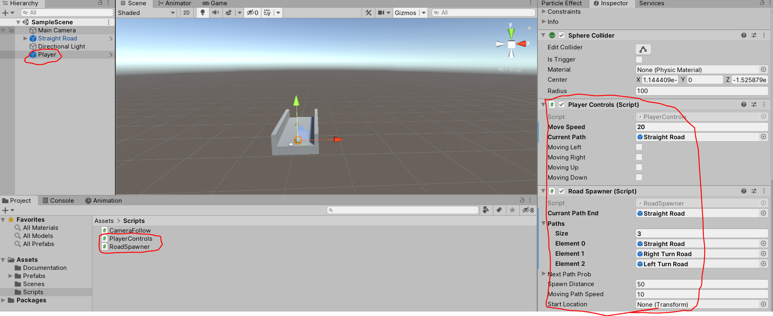

The player game object is **what will spawn the roads and control the character** as the **player** needs to enter an area in order to spawn the road.

The roads do not need to receive any of the scripts, but do add the **CameraFollow** script into the **Main Camera** Game Object as this will allow you a better view of the roads that will be spawning. Be sure to change the Vector3 values of the Off Set section to move the camera out of the character as it will snap inside the player if no value is entered. Also add a value to the Smooth Speed section as this will allow the camera to adjust its position to the character as it moves, but keep it at a number between 0 and 1 because the higher the number, the faster it will self-adjust.

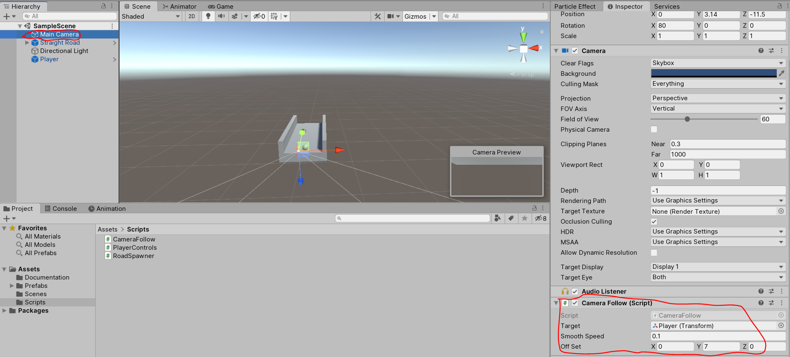

You do not need to move the camera up to get a better view of what is happening. You can choose whatever location you want, but move it through the Off Set value while playing so you can see what the best view for you is.

**Bugs**

There is an issue with the position the roads spawn as they do not spawn in the correct position, except for the straight road, but the roads will still spawn if you back up and go forward again while 3 roads are already spawned.